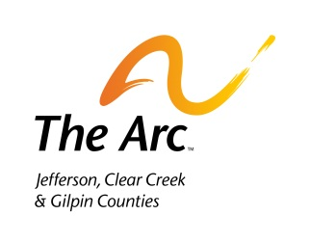
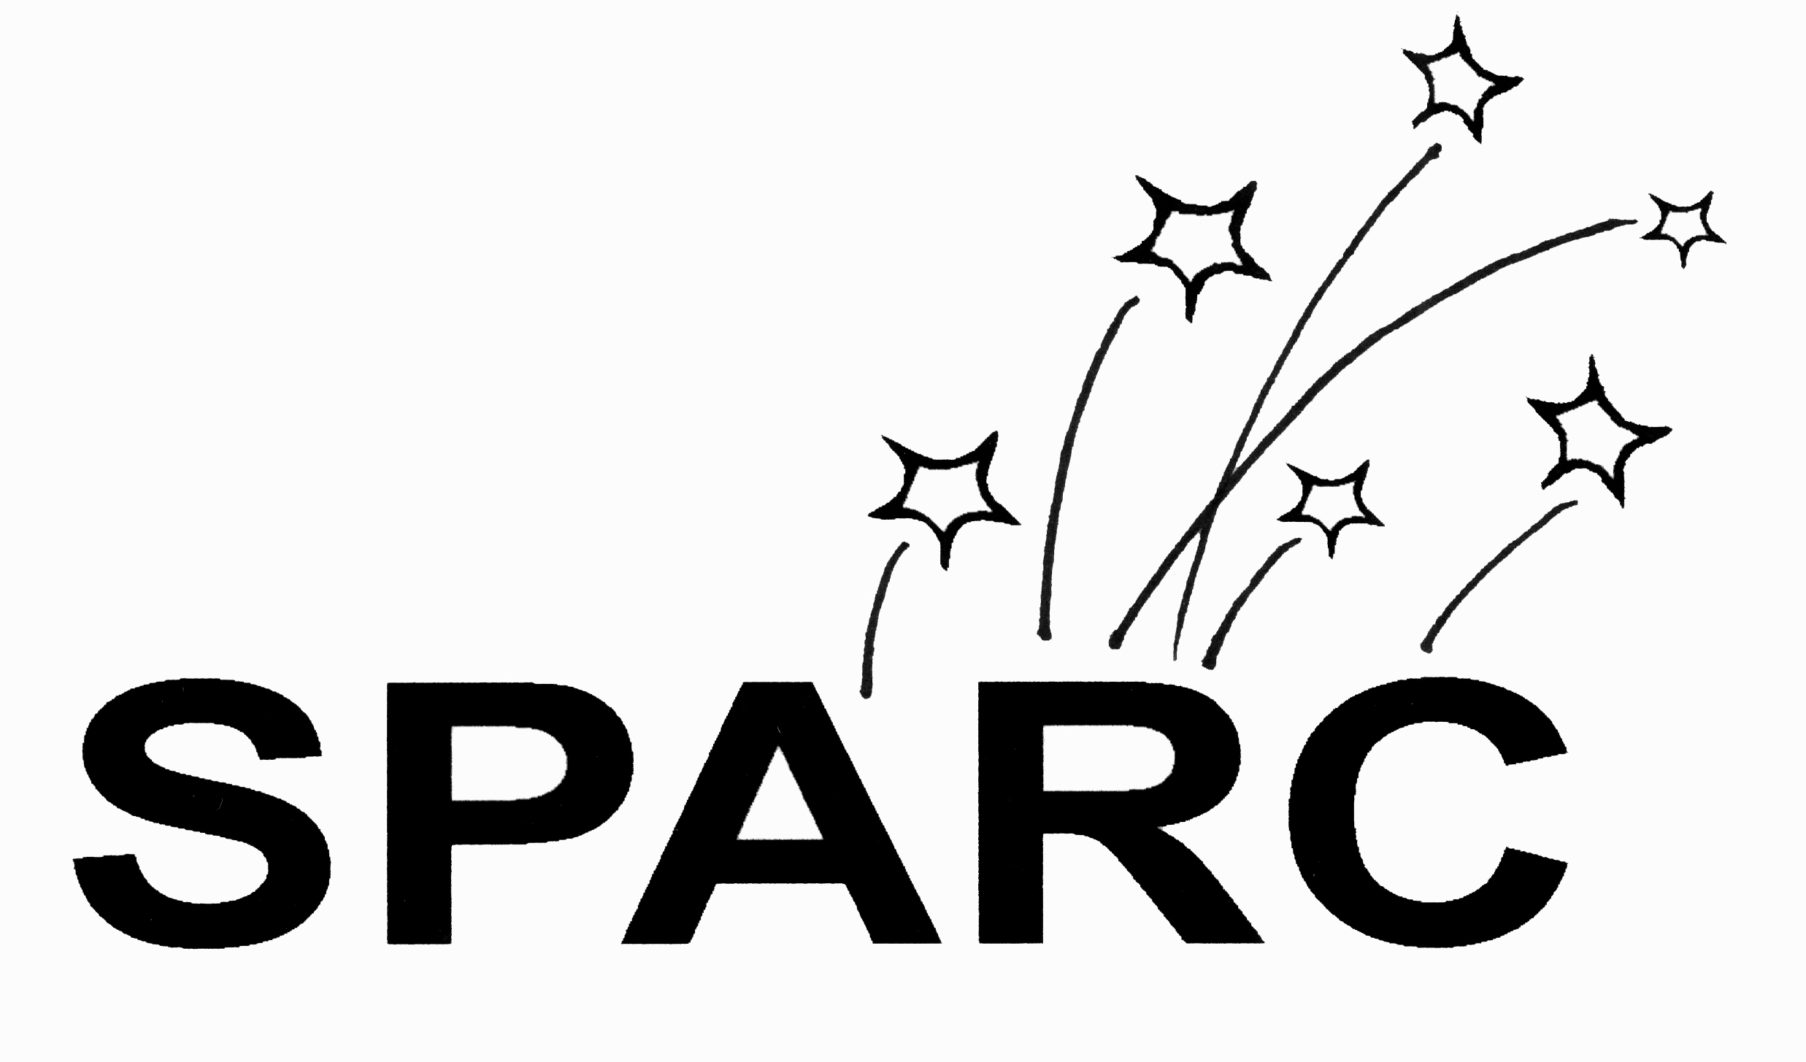

The Arc- Jefferson, Clear Creek & Gilpin Counties’
2018 SPARC Nomination Form
Nominations due by February 14, 2018

Name of Person(s) Submitting Nomination |  | Address/Email |  | Phone
Name of Nominee | Address |  | Email |  | Phone
AWARD CATEGORIES (Please check only one in which your nominee best fits):

Advocacy (Family, Friends, Caregivers)

Community Champion* (Recreation, Church, Volunteer, Partner/Collaborator, etc)

Education* (Local Educator, Administrator)

Employer* (Local Business)

Policy/Legislator (Local Policymaker)

Self-Determination (Self-Advocate)

*Denotes a category that may be an individual/group/organization

Innovation
Please describe and provide specific details as to how your nominee has been innovative in the field of developmental disabilities.

Systemic Change
Please describe and provide specific details as to how your nominee has influenced systems that serve our community (in areas such as education, policy, employment, etc.).

Full Inclusion
Please describe and provide specific details as to how your nominee has promoted full inclusion of persons with developmental disabilities.

Increased Public Awareness
Please describe and provide specific details as to how your nominee has been successful in increasing public awareness of issues affecting persons with developmental disabilities.

Additional Information
Please explain your personal reasons for choosing to nominate this person.

13949 West Colfax Avenue, Denver West Building 1, Suite 150,
Lakewood, CO 80401; info@arcjc.org; or fax 303.232.9370
If you have any questions, please direct all questions to eryn@arcjc.org

